Student’s Name
Professor’s Name
Course
DD MM YY
Assignment 3: Five Cleveland Parks
Introduction
Urban green spaces serve a critical role in enhancing the well-being of the community living around as well as the general society. The urban areas are known for the congestion of buildings, people, factories and vehicles, which are associated with the polluted environment. The green space offers the urban dwellers with the opportune experience to feel the freshness of the free land, recreational advantages and opportunity to forget about the polluted air in the city. This study investigates the five parks in Cleveland, Ohio; South Chagrin Reservation, Edgewater Park, Huntington Beach, Millstream run, and Cleveland Metroparks Zoo. As Daniels explains the green space in the site depicts the beauty of the city, as well as help, protect as well as conserve the natural resources (178). The following section discusses the five parks in Cleveland, Ohio.
The Five Cleveland Parks
South Chagrin Reservation
South Chagrin reservation consists of three great waterfalls; the double-decker fall, Sulphur springs creek, and Quarry rock falls.
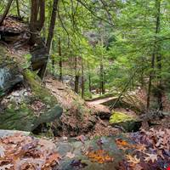
Figure 1: South Chagrin Reservation
The three waterfalls serve the neighbors as well as visitors who come to enjoy the rugged trails that lead through hemlock forests, ravines as well as the coldwater creeks. Some of the key activities that one can enjoy at the park include sledding, horse riding, picnicking, fishing as well as ice fishing among other activities. However, I cannot miss mentioning the outdoor sculpture available at the park, Henry church rock that was curved by Henry church in 1885. I can remember when I first went there; I was attracted to the Burnett historical house as well as Hawthorn ridge sledding hill. At Sulphur Springs picnic area, one can get to join the naturalist Wendy Weirich for a hike through the summer trees. I can attest that this an exquisite experience that one cannot miss tasting when he or she gets to Sulphur Springs waterfalls.
Edgewater Park
The 147 acre Edgewater Park consists of shoreline, dog and swim beaches, fishing pier as well as picnic areas. Edgewater Park has the most incredible and beautiful views that one can ever imagine for. I remember my experience in the site once that left me with a remarkable memory that I cannot forget. I can say that it is a great place to relax as well as have a great view of the Cleveland city. At Edgewater Park, everyone has something to enjoy. The activities ranging from comfortable sand, volleyball courts, and picnic tables in a gorgeous beach that whenever I visit Cleveland I must visit. When I first visited the site, I could get out and I think that anyone else would have the same effect.
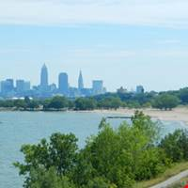
Figure 2: Edgewater beach
Located in the lower Edgewater Park, Edgewater beach offers visitors and Cleveland residents an opportunity to join a pick-up game of the beach while also enjoying the delicious and exquisite delicacies such as a scoop of honey hut ice cream. The 2400 feet beach offers people over 1000 space for swimming. During the evening, I could not do anything but embrace the breath-taking sunset (Cleveland Metroparks).
Huntington
The 103 acres network of spans is an extensive system that preserves nature in the greater Cleveland of Ohio. The site offers different reservations that significantly encircle the greater city of Cleveland. Having been started in the early 1900s as part of Cleveland Metroparks, Huntington has offered both the residents and visitors unlimited access to different activities such as hiking, cycling, boating, running, fishing, as well as other nature enthusiasts.
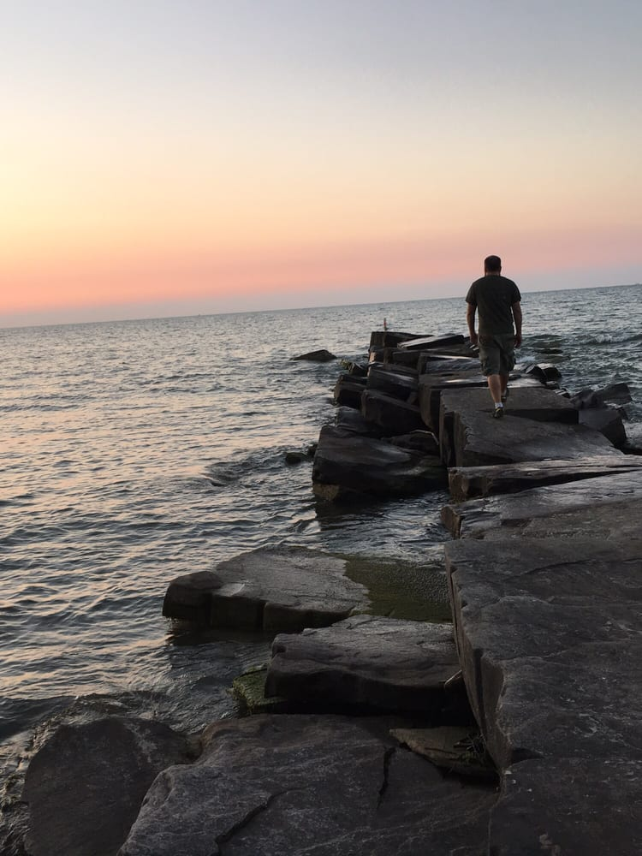
Figure 3: Huntington Beach
Huntington Beach is a friendly place where one can enjoy with family. Located in Bay Village on Lake Erie, Huntington Beach is one of the Cleveland Metropark affiliates, which provides the locals and visitors with an experience where cyclists can enjoy bike riding during the rainy season and also hikers to hike across the Williams Memorial Woods as they enjoy the best view of the park.
Mill Run Stream
Mill Run Stream, a 3,189 acres area is the largest reservation in the Cleveland Metroparks system. The reservation was added in the system in 1976. Located in Berea, Mill Run Stream offers different trails and picnic areas for both residents and visitors who happen to visit the area. Some of the activities in the area include fishing, picnicking, tobogganing, sledding, swimming, mountain biking, and archery.
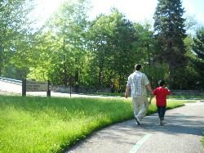
Figure 4: Mill Stream run reservation
The amenities in the area include ball field, fireplace, ice skating area, restrooms, play area, drinking fountain, and many other facilities that help the visitors enjoy their stay in the area. Other significant and remarkable amenities in the area include Albion Woods picnic area where visitors get to enjoy a picnic adventure as they enjoy hiking along the scenic trails.
Cleveland Metroparks Zoo
Founded in 1882, Cleveland Metroparks Zoo is located in a 165-acre space. The park became part of the Cleveland Metroparks in 1993 and is considered one of the most exquisite sites that attract many visitors in North East of Ohio. I recently got the opportunity to visit the Cleveland Metroparks Zoo. I must admit that I have been missing some great things that are offered on the site. I have not been to any zoo before, and this was my first time. The zoo is divided into different areas; Australian adventures, African Savanna, Wilderness Trek, the Primate, Rainforest, and Waterfall Lake among other areas.
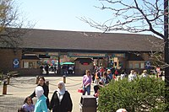
Figure 5: Cleveland Metroparks Zoo entrance
My experience at the zoo was remarkable because I saw different animals including the elephants, lion, and gorilla among other species that I had not seen before. This was a great experience for and I bet it can be for anyone who has never gone to a zoo before. Seeing these animals and watching them stare back at you is a great experience. This is a great place to go with a family or friends, especially on a warmer day to enjoy the view of many animals.
Conclusion
Based on the analysis of the five Cleveland parks, I have realized that a green space may be underestimated but definitely is important. One common feature that all these five sites share is that they provide people with some sense of commonness as they enjoy each of their favorite activities. People come from different places to come and share the amenities in the region. Being able to visit each of these locations is one of the greatest experiences that I have ever felt. Therefore, I realized that many enjoyable things are around us and it just waits for us to explore them.

Works Cited
Cleveland Metroparks. Huntington Beach, 2018. Accessed from https://www.clevelandmetroparks.com/parks/visit/parks/huntington-reservation/huntington-beach
Cleveland Metroparks. Edgewater Park, 2018. Accessed from https://clevelandmetroparks.com/parks/visit/parks/lakefront-reservation/edgewater-park
Cleveland Metroparks. Mill Stream Run Reservation, 2018. Accessed from https://www.clevelandmetroparks.com/parks/visit/parks/mill-stream-run-reservation
Cleveland Metroparks. North Chagrin Reservation, 2018. Accessed from https://clevelandmetroparks.com/parks/visit/parks/north-chagrin-reservation
Cleveland Metroparks. Zoo, 2018. Accessed from https://clevelandmetroparks.com/zoo
Daniels, Thomas L. "A trail across time: American environmental planning from city beautiful to sustainability." Journal of the American Planning Association 75.2 (2009): 178-192.

Figures
Figure 1. South Chagrin Reservation [Photograph found Cleveland]. Accessed from https://clevelandmetroparks.com/parks/visit/parks/north-chagrin-reservation
Figure 2. Edgewater Beach [Photograph found in Cleveland]. Accessed from https://clevelandmetroparks.com/parks/visit/parks/lakefront-reservation/edgewater-park
Figure 3. Huntington Beach [Photograph found in Cleveland]. Accessed from https://www.clevelandmetroparks.com/parks/visit/parks/huntington-reservation/huntington-beach
Figure 4. Mill Stream Run Reservation [Photograph found in Cleveland]. Accessed from https://www.clevelandmetroparks.com/parks/visit/parks/mill-stream-run-reservation
Figure 5. Cleveland Metroparks Zoo Entrance[Photograph found in Cleveland]. Accessed from http://www.clemetzoo.com/

